# Third party Tools with FPOD.exe

Third party tools can be accessed under the export tab and the “Access third party analysis tools” button in the bottom right of the panel. These tools are useful for extracting data for third party analysis, reclassifying trains and for checking the data for individual trains and encounters. This guide provides quick step by step guides for both the import and export, followed by a more detailed guide for both.

This will open up a second window allowing you to either open up the Third Party Export page or the Third Party Import page. These is a brief description of them both with very basic instructions of how to use them.

## Third Party Export

### Quick step by step

**FP3 features export (A)**

1. Top Panel
   1. Select how you want the data to be exported (One text file for each FP3, one text file for all data, or to the clipboard).
   2. If exporting all data to one file, input a file name to save the data to.
2. Bottom Panel
   1. If you have previously saved an export features settings file (.tpe3 file), press load settings and select the file containing the relevant settings and skip to step 3
   2. Input a species text to output on each row of data.
   3. Select the max length of an encounter by setting “Split encounters at… mins”.
   4. Set the minimum time needed between encounters by setting the “Gap between encounter > … mins”.
   5. Select an export level from either “File”, Minute”, “Encounter”, “Train” or “Click” features and select the features you wish to export (can only do one level at once).
   6. (Optional) Save your export features settings to file (.tpe3 file) for quicker exporting in the future.
3. Middle panel
   1. Press “A: Export FP3 features” and select the files to be exported and the location to save the file/s if applicable.
4. Sit back and watch as the data is exported to your preferred format.

**Kerno-F derivatives export (B)**

1. Top Panel
   1. Select One text file for all FP3 files
   2. Input a file name to save the data to.
2. Middle Panel
   1. Press “B: Export KERNO-F derivatives” and select the FP1 files to be exported and the location to save the file/s if applicable.
3. Sit back and watch as Kerno-F runs.

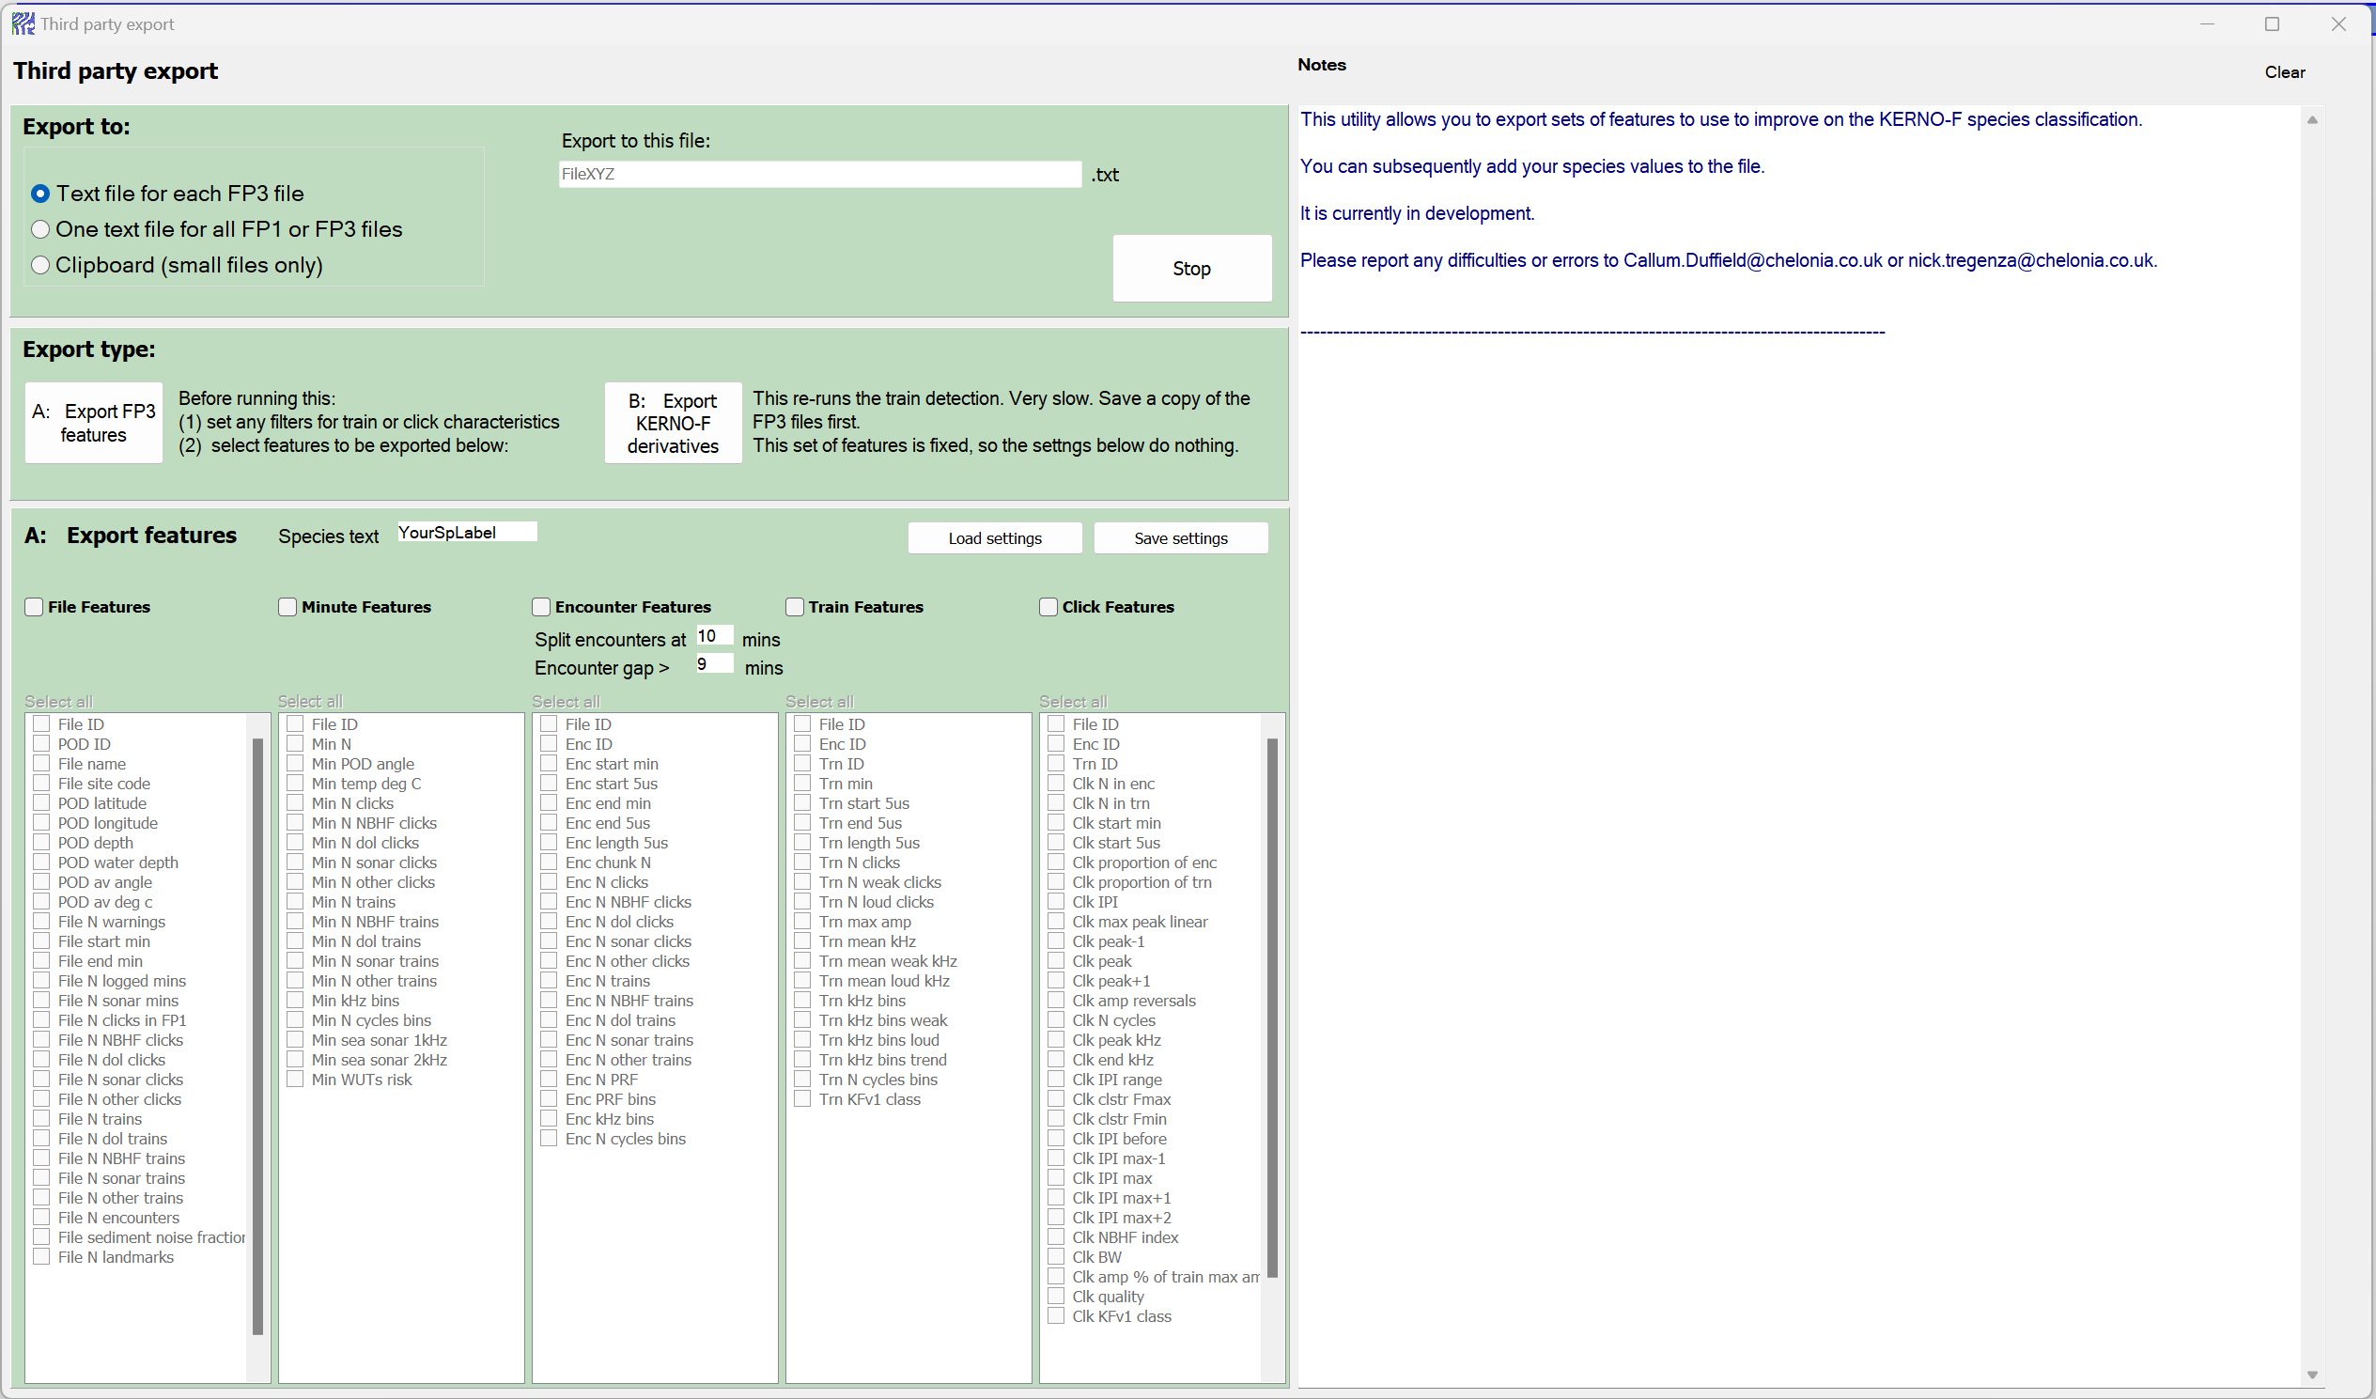

## Third Party Import

The third-party import tool is to import train classifications that a third-party method has assigned to trains identified by KERNO-F. This may be required in locations with high levels of sediment transport noise where Kerno-F struggles to separate noise from cetaceans or it could be as simple as reclassifying all cetacean detections with a single species name where only one species occurs.

### Quick step by step

1. Set and confirm the classifications either by inputting them into the provided field or loading them from a previously saved .tpi3 file. You can use a classification code as well or classification text - check “Show/Hide Species codes” to view the default codes and associated class.
2. Import the data containing the trains and their new classifications.
3. Select the FP3 files and reclassify the trains in them.

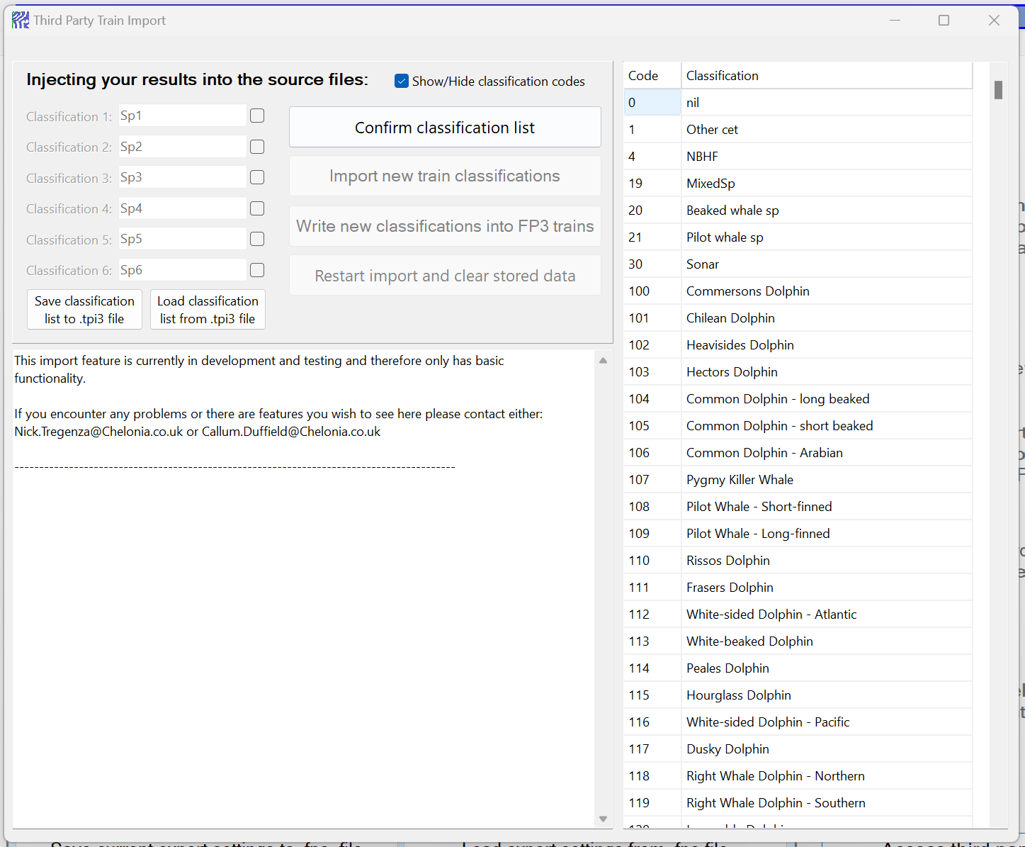

## Third Party Export full guide

Using the third party Export tool gives you the opportunity to export a list of features that are stored in FP3 files or derivatives that are produced by the Kerno-F classifier from FP1 files. There are three main sections to this form, the export file settings in the top panel, the export buttons in the middle panel and the FP3 features in the bottom panel. There is also a window that will display progress, notes and errors on the right.

Top Panel:

In the top panel you can decide how data is exported and where appropriate set a file name. In this panel there is also a button to safely halt the export procedure. You can choose between one of three export formats:

**One single text file** - Reduces the number of files but can produce very a large file if data from many files are being exported. The file name should be inputted into the box next to “Single text file”.

**A text file for each Fp1/3 file** – Ensures the size of the files are openable by text editors. Each file will have the same name as the input file but with an identifier on the end of the name to distinguish the type of data/features it contains.

**Clipboard** – Very quick and can be pasted straight into an excel document. Limited to 10,000 lines of data.

### Exporting Kerno-F derivatives

Exporting the KERNO-F derivatives is the export that requires the least number of steps but provides a wealth of derivatives (>100) that are produced when KERNO-F is identifying and classifying trains. Using the controls in the red box, firstly select “One text file for all FP3 files” and set the file name the data should be saved to under “Export to this file”. At present this is the only way that Kerno-F derivatives can be exported. Once these are set, press “B: Export KERNO-F derivatives” and watch as the data is exported. If you have a lot of files, it is suggested that you do this in batches. To safely stop the export, use the “Stop” button at the top of the main FPOD.exe window.

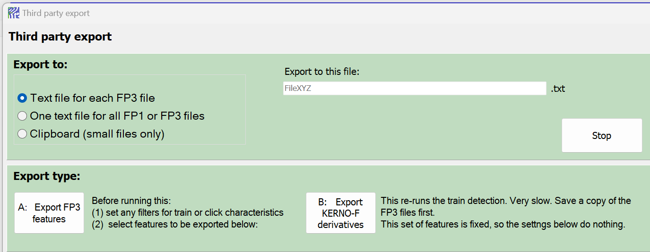

### Exporting FP3 features

Exporting features stored in FP3 files can give access to over 100 features across different export levels (Files, Minutes, Encounters, Trains and clicks). Each of these levels have IDs within them that can be used to match data between levels (ie the File ID in Minute features can be used to match up with data of the same File ID in File features, much like a relational database). There are a couple of things that need to be considered when exporting FP3 features. Firstly, any filters set in the “Filters +Files” tab and species/quality check boxes will be used to filter the export data. Secondly, the values under “Split encounters at xx mins” and “Encounter gap > xx mins” will affect data in Encounter, Train and Click feature exports. For both of these considerations, if you wish to merge these exports at a later date, ensure that these settings are kept the same for all feature level exports otherwise ID numbers will not match between feature levels.

1. Select how you want the data to be exported. If exporting the data from each FP3 file into its own text file, the feature level (either Files, Minutes, Encounters, Trains or Clicks) will be appended to each file name.
2. If you select “One text file for all FP3 files” you will need to enter a file name under “Export to this file:”.
3. Now go to the bottom panel
4. In the “**Species text**” box, add in the species name you would like to use. This will be on each row of the data export.
5. Set the max length of an encounter in the “**Split encounters** at… mins”. Periods of consecutive trains longer than this will be split into multiple encounters.
6. The “**Gap between encounters**” sets the length of time that’s needs to pass without a detection positive minute before a new encounter is started.
7. Next you need to select at what level of detail you wish to export the data. Each row of the export file will contain features at either a “**File**”, “**Minute**”, “**Encounter**”, “**Train**” or “**Click**” level.
8. Once you have selected the level you wish to export at, you can select the **features** of interest. If you wish to export data at multiple levels, the export will need to be repeated for each level and then the data can be merged using the relational columns “File ID”, “Enc ID” and “Trn ID”. However, ensure the filters in the “Filters +Files” tab, the Species and Quality checkboxes on the left of the main page and the Encounter values are all the same for all export levels otherwise IDs will not match up.
9. Go to the middle panel and press “A: Export FP3 features”
10. If you have selected to export the data to a file/files, you will be asked to select a location to save the files.
11. Select the files you wish to extract the features from.
12. In the “Notes” panel you will get updates as the export runs through the files and notifications if any errors occurred.
13. To safely stop the export, use the “Stop” button in the top panel of the “Third party export” window.

## Third Party Import full guide

1. Set the species categories to be assigned. The first time you do this, you will need to input the species names or species codes (listed at the end of this document) into the 6 species class fields. If you have saved a species list previously, you can import this list by pressing “Load species classes from file” and selecting the relevant .tpi3 file.
2. Hit “confirm species”. This will check the species/codes provided and ensure that they are all valid.
3. (Optional) Save your species list. Once you have inputted your species into the fields, you can save them to a file (.tpi3) for quicker and more consistent importing in the future by pressing “Save species classes to file”.
4. A screenshot of a computer

   Description automatically generatedRead in a “.tsv” or “.csv” document that contains the list of trains for reclassification by pressing “Import new train species classes”. The column names do not matter, but the order of the columns does, so ensure that the file name is in column 1, the train minute number in column 2, the 5us start time of the train in column 3 and the classification is in column 4. Any further columns will be ignored. The classification can either be as text or using the species codes listed below. Any classifications not in the list at the end of this document will be stored in the user defined slots (246-251).
5. A screenshot of a computer

   Description automatically generatedOnce the file is read in, the notes panel will display a list of all the data read in, the file names and the number of associated trains for each classification. Unclassed will always be the first class.
6. FP3 files can now be selected for assigning the new classifications to by selecting “Write new classifications into FP3 trains”. This will clear any previously set third party classifications. If a train in the FP3 file is not listed in the new classifications, it will be set to unclassed.

If at any point after confirming the species list you realise a mistake was made, press “Restart import and clear stored data” to start again.

List of classifications and their codes that can be used for the Third party import

|  |  |  |  |  |  |
| --- | --- | --- | --- | --- | --- |
| Code | Classification | Code | Classification | Code | Classification |
| 0 | nil | 140 | Finless Porpoise | 226 | behaviour 1 |
| 1 | Other cet | 141 | Spectacled Porpoise | 227 | behaviour 2 |
| 4 | NBHF | 142 | Harbour Porpoise | 230 | GpSize 2 |
| 19 | MixedSp | 143 | Vaquita | 231 | GpSize 3-4 |
| 20 | Beaked whale sp | 144 | Burmeisters Porpoise | 232 | GpSize 5-8 |
| 21 | Pilot whale sp | 145 | Dalls Porpoise | 233 | GpSize 9-16 |
| 30 | Sonar | 146 | Sperm Whale | 234 | GpSize 17-32 |
| 100 | Commersons Dolphin | 147 | Sperm Whale - Pygmy | 235 | GpSize >32 |
| 101 | Chilean Dolphin | 148 | Sperm Whale - Dwarf | 246 | User Defined |
| 102 | Heavisides Dolphin | 149 | Amazon River Dolphin | 247 | User Defined |
| 103 | Hectors Dolphin | 150 | Bolivian River Dolphin | 248 | User Defined |
| 104 | Common Dolphin - long beaked | 151 | Baiji | 249 | User Defined |
| 105 | Common Dolphin - short beaked | 152 | La Plata Dolphin | 250 | User Defined |
| 106 | Common Dolphin - Arabian | 153 | Ganges and Indus River Dolphin | 251 | User Defined |
| 107 | Pygmy Killer Whale | 154 | Arnouxs BW |  |  |
| 108 | Pilot Whale - Short-finned | 155 | Bairds BW |  |  |
| 109 | Pilot Whale - Long-finned | 156 | Bottlenose Whale - Northern |  |  |
| 110 | Rissos Dolphin | 157 | Bottlenose Whale - Southern |  |  |
| 111 | Frasers Dolphin | 158 | Indo-Pacific BW |  |  |
| 112 | White-sided Dolphin - Atlantic | 159 | Sowerbys BW |  |  |
| 113 | White-beaked Dolphin | 160 | Andrews BW |  |  |
| 114 | Peales Dolphin | 161 | Hubbs BW |  |  |
| 115 | Hourglass Dolphin | 162 | Blainvilles BW |  |  |
| 116 | White-sided Dolphin - Pacific | 163 | Gervais BW |  |  |
| 117 | Dusky Dolphin | 164 | Ginkgo-toothed BW |  |  |
| 118 | Right Whale Dolphin - Northern | 165 | Grays BW |  |  |
| 119 | Right Whale Dolphin - Southern | 166 | Hectors BW |  |  |
| 120 | Irrawaddy Dolphin | 167 | Layards BW |  |  |
| 121 | Snubfin Dolphin | 168 | Trues BW |  |  |
| 122 | Killer Whale | 169 | Perrins BW |  |  |
| 123 | Melon-headed Whale | 170 | Pygmy BW |  |  |
| 124 | False Killer Whale | 171 | Stejnegers BW |  |  |
| 125 | Guiana dolphin | 172 | Spade Toothed Whale |  |  |
| 126 | Tucuxi | 173 | Tasman BW |  |  |
| 127 | Humpback Dolphin - Pacific | 174 | Cuviers BW |  |  |
| 128 | Humpback Dolphin - Indian | 214 | JetSki |  |  |
| 129 | Humpback Dolphin - Atlantic | 215 | BtLarge |  |  |
| 130 | Spotted Dolphin - Pantropical | 216 | BtMed |  |  |
| 131 | Clymene Dolphin | 217 | BtNoEngine |  |  |
| 132 | Striped Dolphin | 218 | BtOther |  |  |
| 133 | Spotted Dolphin - Atlantic | 219 | BtSmall |  |  |
| 134 | Spinner Dolphin | 220 | BtTrawling |  |  |
| 135 | Rough-toothed Dolphin | 221 | BtWatching |  |  |
| 136 | Bottlenose Dolphin - aduncus | 222 | Breaching |  |  |
| 137 | Bottlenose Dolphin - truncatus | 223 | Feeding |  |  |
| 138 | Beluga | 224 | Logging |  |  |
| 139 | Narwhal | 225 | Milling |  |  |